with A Guide to DUDL Middle School Congressional Debate
Written by
Gillian Breuer
PJ Nyland

The Denver Urban Debate League * DUDL @ DU Sturm College of Law * 2255 East Evans, Suite 406 * Denver, CO, 80210 * www.DenverDebate.org * 303.871.6575 * JessicaClark@UrbanDebate.org
Jessica A. Clark, Executive Director Roberto Corrada & Hank Provost, Co-Chairs, Board of Directors

Registration Packet for DUDL’s February 22, 2020 Middle School Competition

2020
Contents
Why Should I do Middle School Congress? 4
Registration Forms 5
DUDL “Your City Council” Registration Form 6
DUDL Parental Medical Release Form 7
DUDL Parental Media Release Form 8
Schedule 9
A Middle School Guide to DUDL Congress 10
What Will We Debate? 10
A Bill to Allocate More School Funds Towards Playground Construction 11
A Resolution to Invest in Youth Experiencing Homelessness in Colorado 11
A Resolution to Engage in Climate Strikes 13
How Do I Write My Own Legislation? 14

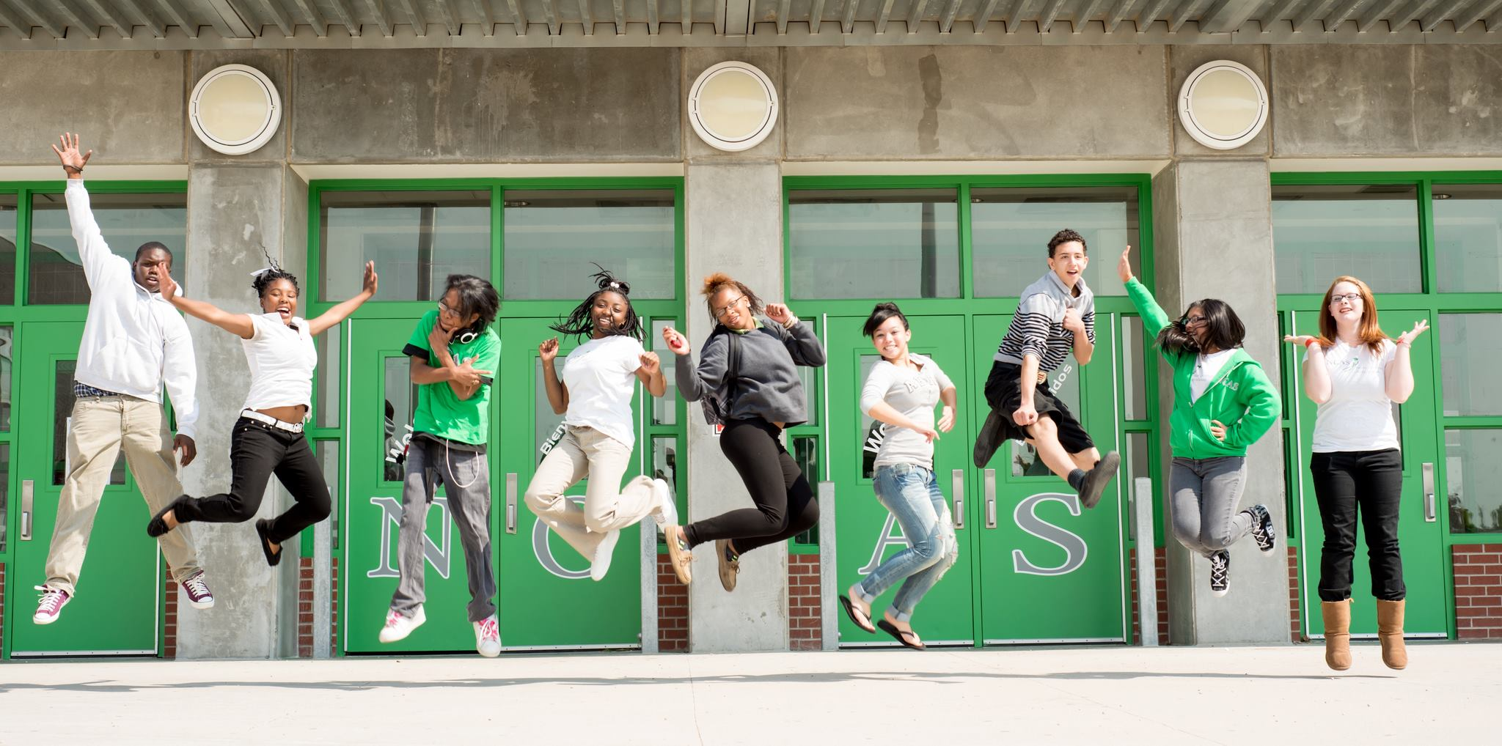

Why Should I do Middle School Congress?
Welcome!
We are so glad that you are interested in fostering great research, advocacy, and public speaking skills by participating in the Denver Urban Debate League’s Middle School Congress Event. This year, the name of our event is “Your City Council,” because the city belongs to you: the citizens of tomorrow. Congressional Debate, or Student Congress, is an event that thousands of high school and middle school students across the nation compete in every year. Meant to simulate the real United Sates Congress, Congressional Debate is a great opportunity to learn about how the laws are made. The concept of debate and public speaking may sound intimidating at first, but the DUDL “Your City Council” Debate is an inclusive and low-pressure introduction to the activity. Middle School students from across Denver will come together to offer their thoughts and opinions on issues that are important to Denver-ites.

The DUDL “Your City Council” Debate will be held on February 22nd, 2020, from 12:30-4:30pm at Dr. Martin Luther King Jr. Early College. There is no cost to attend. Lunch and trophies will be provided. All middle school students must complete attached registration forms and be accompanied by a parent or school chaperone for the duration of the competition. The school registration form must be completed by Monday February 17, 2020. We hope to see you soon!

Sincerely,
The DUDL Staff

Registration Forms

Online registration to be completed by teachers (one for school) or parents/guardians can be found at the following link, and is also included below:
https://forms.gle/3TBzYgfMaRPb5c5e9
Please note: All participants must have a parent or guardian sign the medical release the media release forms below and bring a copy to the tournament. A copy of both the release forms in both English and Spanish can also be found at:
http://www.denverdebate.org/uploads/4/3/0/1/43015255/dudl_permission_for_medical_care.pdf
http://www.denverdebate.org/uploads/4/3/0/1/43015255/dudl_parental_consent_form.pdf

DUDL “Your City Council” Team Registration Form

The DUDL “Your City Council” Debate will be held on February 22nd, 2020, from 12:30-4:30pm at Dr. Martin Luther King Jr. Early College. There is no cost to attend and lunch and trophies will be provided. All middle school students must complete this registration form, the medical release form, and the media release form and be accompanied by a chaperone for the duration of the competition. We hope to see you soon!

Student(s) Name(s) and School/Grade

__________________________

__________________________

Total Number of Students:
________
Coach/Parent/Chaperone(s) Name(s)

Coach/Chaperone/Parent Email

Chaperone(s) Phone Number for February 22nd

Do you have any speech or debate experience?
Yes No

Will you be submitting Legislation?
A guide to writing legislation can be found in the Guide to Middle School Congress at www.denverdebate.org. Email legislation to dudlvolunteers@gmail.com by February 17th.
Yes No
Why are you participating in “Your City Council”?

DUDL Parental Medical Release Form

If you are under 18 years of age it is necessary for a parent or guardian to sign the permit below for you to receive medical care should it become necessary.

I grant permission for _____________________________ (name of student) to receive medical care from Denver Urban Debate League staff or any off-campus medical care provider while he/she at a DUDL event. I also authorize such treatment, x-rays or other diagnostic studies as, in the judgment of the attending physician, may reasonably be necessary to preserve and protect the student’s health.
Emergency Contact Name: ___________________________
Phone #1: ______________________ Phone #2 __________________________
Secondary Emergency Contact Name: _______________________________________________ Phone #1 ____________________ Phone #2 _____________________________

Signature of parent or guardian: __________________________ Date: ______________ Relationship to student: ____________________________________________________ Address: ________________________________________________________________
Phone: _____________________________ Email: _____________________________
Student health information:
Student Date of birth: _______________ Allergies: ____________________________________ Description of allergic reaction: ____________________________________________________ Other medical condition to be aware of: _____________________________________________
Any other information we should know:

DUDL Parental Media Release Form

Part One: Privacy and Communication with Minors
Please initial to indicate your consent.
I am giving permission for the Denver Urban Debate League to communicate directly with my child(ren) online, via email and other media, for the purposes of program development and evaluation. Part Two: Media Release Statement Please initial each line to indicate your consent.

Part Two: I am giving permission for the Denver Urban Debate League to publicly use:
Please initial each line to indicate your consent.
_____ Photograph(s) of my child(ren)
_____ Original creations written or developed by my child(ren)
_____ News stories about my child(ren)

In making my decision, I declare that I am the child(ren)'s legal guardian and have the legal authority to give such permission.

Name(s) of child(ren) _________________________ _________________________

_________________________ Signature of parent/guardian

_____________________________ Printed name of parent

___________________________ Date

Schedule

“Your City Council” Debate Schedule
Dr. MLK Jr. Early College 19535 E 46th Ave
Registration in the North Lobby (Entrance near Bus Drop-off)
12:30PM-1:30PM Registration and Lunch
1:30PM-2:30PM Instructional Session with Coach Mayen
2:45PM-4:00PM “Your City Council” Debate
4:00PM-4:30PM Awards and Recognition

A Middle School Guide to DUDL Congress
Adapted from the NSDA Middle School Guide to Congress
Event Description: A series of bills and resolutions have been chosen to represent issues key to Denver. Debaters (also referred to as Senators and Representatives) alternate delivering speeches for and against the topic in a group setting. A high school student or coach will serve as a presiding officer (PO) to ensure debate ﬂows smoothly. Students are assessed on their research, argumentation, and delivery skills, as well as their knowledge and use of parliamentary procedure.
Basic Proceedings: Congressional Debate is like a simulation of the real United States legislature. A group of 10-25 students, called a Chamber, will compete in a legislative session. A series of bills and resolutions will be provided to students. Students in turn will be selected by the presiding officer to give speeches both advocating for and encouraging the defeat of the measure in front of them. Following each speech, competitors will be able to pose questions of the speaker. Once debate is exhausted on a particular item, the chamber will vote either to pass or fail the legislation, and debate moves on to the next item.
Speaking: Speeches shall not exceed three minutes in length. The ﬁrst two speeches on a piece of legislation are known as the ﬁrst advocacy, or ﬁrst pro, and the ﬁrst rejection, or ﬁrst con. These speeches are followed by 2 minutes of cross examination. After the ﬁrst pro and con speech are established, each additional speaker is subject to one minute of cross examination by the chamber. The PO selects the members of the chamber to ask the questions of the speaker.
Speech Structure: A Congress speech typically consists of an introduction, a series of arguments and a conclusion. The introduction should be a succinct overview of what is to come in the speech—an attention-getter to get the audience focused, a clear thesis statement, and a preview of the arguments to come. Try to contain the introduction to about 30 seconds—anything longer than that eats up valuable time for content!
Each argument consists of a claim, backing to support that claim, a warrant, and one or more impacts. The claim is simply the argument being made—without support though, the claim is not inherently valid. Thus, it needs backing, or logic and evidence to support why the claim is true. The warrant connects the backing to the claim—it serves as support for why the backing is relevant to the claim.
Congress speeches end with a conclusion that recaps the main points, repeats the introduction, and ties the speech together thematically.

What Will We Debate?

A Bill to Allocate More School Funds Towards Playground Construction

BE IT ENACTED BY THE CONGRESS HERE ASSEMBLED THAT:
Section 1. As school funding is limited, but infrastructure suffers from a lack of adequate playground equipment, the Denver Public School board will mandate that 10% of all total allocated funds will go towards creating and maintaining school playgrounds.
Section 2. Total allocated funds will be defined as the fiscal budget for one year given to each school.
Section 3. Denver Public Schools will ensure that each school appropriately spends funds allocated for playground construction and maintenance.
- Elementary, middle, and high schools will all be expected to create and maintain playgrounds, sports fields, and other recreational facilities.
- Should 10% of funds not be available for playground construction, the money will be cut from academic programs.
SECTION 4. This bill will go into effect for the 2020-2021 school year.
Section 5. All laws in conflict with this legislation are hereby declared null and void.

A Resolution to Invest in Youth Experiencing Homelessness in Colorado

WHEREAS, Colorado school districts identify 24,685 youths experiencing homelessness; and it is the responsibility of the state to ensure that all of its citizens are guaranteed the basic right to housing
WHEREAS, Organizations like Urban Peak, The Colorado Coalition for the Homeless, and the Denver Rescue Mission help vulnerable youth in the state; and are currently looking to expand their programs but lack the funding, resources, and support necessary to do so
WHEREAS, Homelessness can make it difficult for youths to learn in schools; and education is a pre-condition to many traditional indicators of success
WHEREAS, Homelessness in this state has been overly criminalized; now, therefore, be it that the state should support rather than ignore its homeless youths
RESOLVED, By the Congress here assembled that youth experiencing homelessness in Colorado should be better supported by organizations directed at assisting such youth.

A Resolution to Engage in Climate Strikes

WHEREAS, Youth across the country are engaging in climate strikes; and they believe that the government is not actively addressing issues of climate change
WHEREAS, 98% of scientists believe that global climate change is real and anthropogenic
WHEREAS, Many youths are penalized for missing school for engaging in the climate strikes; and their grades or academic prospects may suffer as a result
WHEREAS, Youths should be permitted to engage in civil disobedience now, therefore, be it that youths should share the same freedoms to protest as adults
RESOLVED, By the Congress here assembled that youths should not be penalized in any way for engaging in climate strikes

How Do I Write My Own Legislation?
Definitions:
- Bill: legislation that describes details and specifics of how a law/policy would be enacted.
- Expression of acceptance, conviction or value of belief that urges further action
Key difference is that Bills offer specific policy plans and ideas such as a budget, law changes, consequences to failing to uphold said law, etc. Bills are more focused on symbolic statements framed in moral argumentation and less concerned about actively solving situations. For example, a bill to decrease climate could include:
- And Budget increase for the National Oceanic and Atmospheric Association
- A fine of 2500 dollars for anyone who is caught practicing unsustainable methods, followed by two years of jail time following three strikes.
- 5% decrease to the amount of carbon production by corporations or face fines.
A resolution on the other hand would lack these details and instead would include…
- Statements of support “Whereas climate change is an increasingly pressing issue and;
- “Whereas the Australian Outback Fires show the potential ecological harm of uncontrolled environmental change”
- “Resolved, by the congress here assembled that Climate Change be an increasingly addressed issue in future legislation.”
General Formatting:
- Both bills and resolution should not be longer than 1 page.
- All should be clear and concise, appropriately listing definitions when applicable.
- Bills should include
  - Data and examples
  - A budget and timeline
  - Consequences for breaking the law
  - What the bill is specifically designed to fix, be specific.
- Resolutions should include
  - Why this problem should be addressed from a moral view
  - Examples of Harms against specific Populations
See templates below as well as example legislation.

A Bill to [Action Word] [article] [Object] to
[Summarize the Solution Specifically]

BE IT ENACTED BY THE CONGRESS HERE ASSEMBLED THAT:
Section 1. State the new policy in a brief declarative sentence, or in as few sentences as possible.
Section 2. Define any ambiguous terms inherent in the first section.
Section 3. Name the government agency that will oversee the enforcement of the bill along with the specific enforcement mechanism.
- Go into further details if necessary.
- Go into further details if necessary.
SECTION 4. Indicate the implementation date/timeframe.
Section 5. All laws in conflict with this legislation are hereby declared null and void.
Introduced for Congressional Debate by _____

A Resolution to […]
WHEREAS, _____; and
WHEREAS, _____; and
WHEREAS, _____; and
WHEREAS, _____; and
WHEREAS, _____; and
WHEREAS, _____; and
WHEREAS, _____; and
WHEREAS, _____; now, therefore, be it
RESOLVED, By the Congress here assembled that _____.
Introduced for Congressional Debate by _____
For examples of Bills and Resolutions see examples from one of these topics.
https://www.speechanddebate.org/wp-content/uploads/Nationals-2018-HS-Legislation-Docket.pdf

